**NAME -** Kanishk Vardhan Singh

**SUPERSET ID-** 6365335

***Nunit- HandsOn***

***TestFixture & Test***

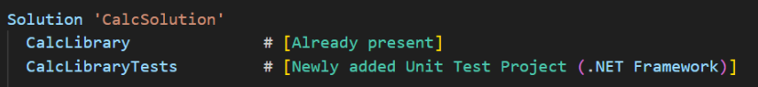

Adding the CalcLibrary project as a reference

Screenshot 2025-06-29 195118

**Creating** CalculatorTests.cs

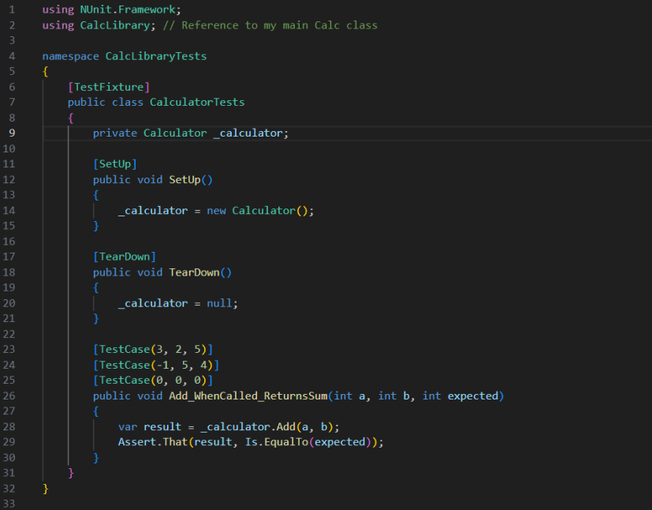

Output:

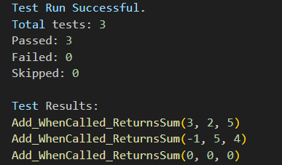

CalcLibrary/Calculator.cs

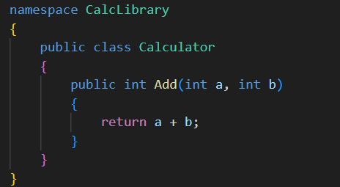

***Moq- HandsOn***

**Write Testable Code with MOQ**

Creating MailSender.cs

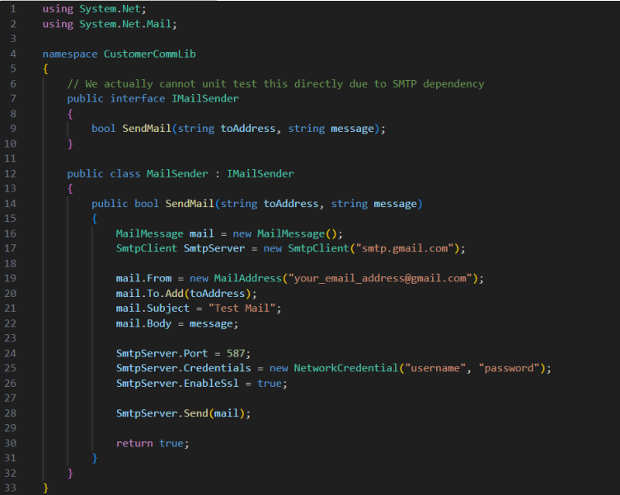

Creating Customercomm.cs

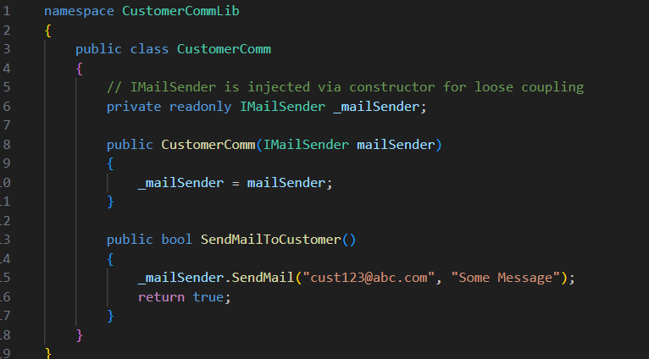

Creating Unit Test Project **CustomerCommTests.cs**

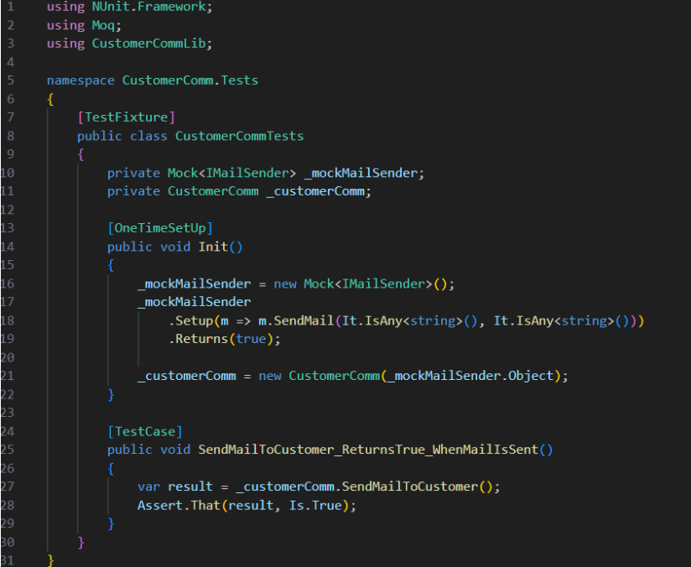

Output:

